employee (ID, person_name, street, city)
works (ID, company_name, salary)
Figure 1
- (20%) Consider the employee database with two relations in Figure 1.
- Write a function avg_salary that takes a company name as an argument and finds the average salary of employees at that company.
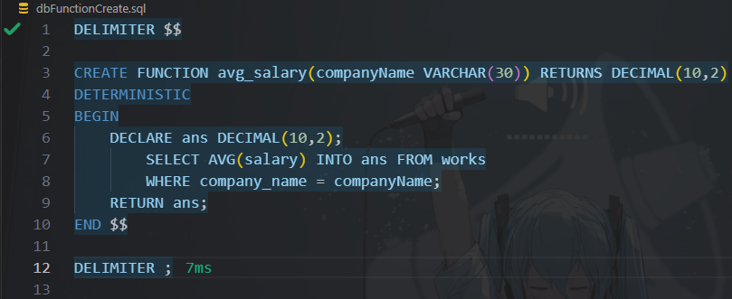

- Write an SQL statement, using the avg_salary function, to find companies whose employees earn a higher average salary than the average salary at“FirstBank”.

- (20%) Design a database using the ER-diagram for an airline. The database must represent the information of each flight (航班), including its flight number and schedules (起飛降落的日期時間). The database also needs to keep track of customers and their reservations on individual flights, including the status and seat assignments. (Design the proper entity sets and relationship sets. For each entity set, represent the proper primary key and attributes.)
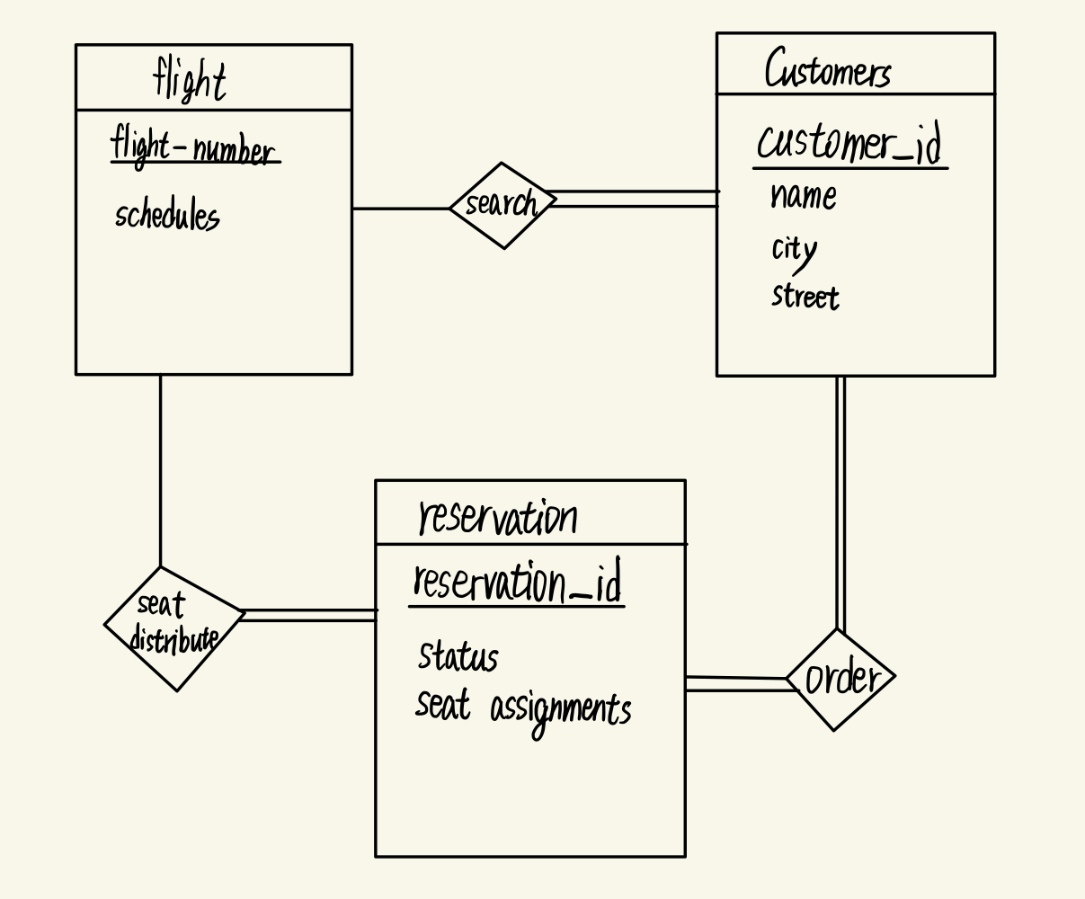
首先解釋entity，考慮即使單一航班也可能發生單人訂多張票的情況，reservation應該為entity，而非relation。
而customers與flight間存在可互相查詢對應的search關係，每個顧客都應該透過flight-number找到自己搭乘的flight，故search右方為total participation，flight上的座位不一定要對應到顧客 (座位未售出)，可能因時段或重大變故，出現某航空公司發出乘客數為0的航班。
對於reservation左方的seat distribute來說，所有預定應對應到flight上，不可開出沒售出的座位票，相對於flight來說，可以有座位是未售出的，因此非total participation。
對於reservation右方的order來說，所有的預定應找的到對應的顧客 (total participation)，所有顧客也應可以對應到自己的預訂紀錄，因此也為total participation。

- (20%) Construct appropriate relational schemas for the E-R diagram in Figure 2. For each relational schema, represent the proper attributes and primary key.
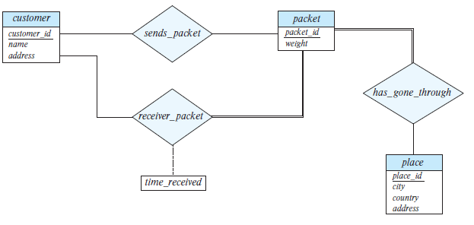
Figure 2
Sends_packet | Sends_packet(customer_id, packet_id)
Receiver_packet | Receiver_packet(customer_id, packet_id, time_received)
Has_gone_through | Has_gone_through(packet_id, place_id)
Customer | Customer(customer_id, name, address)
Packet | Packet(packet_id, weight)
Place | Place(place_id, city, country, address)

- (20%) List two nontrivial functional dependencies satisfied by the relation in Figure 3. Explain your answer.
A | B | C
a1 | b1 | c1
a1 | b1 | c2
a2 | b1 | c1
a2 | b1 | c3
Figure 3

A -> B | B不被包含在A裡，但可以透過A推出唯一的B (a1->b1, a2 ->b1)
C -> B | B不包含於A，但C唯一對應到B (c1 -> b1, c2 -> b1, c3 -> b1)

- (20%) Consider the schema R = (A, B, C, D, E, G) and the set F of functional dependencies as follows:
{AB → CD, B → D, DE → B, DEG → AB, AC → DE}.
- Prove that AB is not a superkey.
- AB藉AB → CD獲得CD
- AB已經有B，不須藉B → D獲取D
- ABCD藉AC → DE獲得DE
- ABCD已經有B，不須藉DE → B獲取B
- ABCDE無法獲得G
以上推斷，可知無法cover所有的attribute，非superkey

- Prove that DEG is a superkey.
1. DEG藉DEG → AB獲取AB
2. ABDEG藉AB → CD獲取C
以上推斷，可知DEG可以cover所有attribute，為superkey

